112學年度第1學期 關鍵材料學位學程博士班資格考
2023 Fall Semester Program on Key Materials PhD Qualifying Exam
結果公告
The Results 20231016
考試科目 Subject:  固態物理  Solid State Physics | 通 過 學 生  Passed
1 申請修課抵免  waive the exam by coursework | M48121516  M48114014
2 申請論文抵免  waive the exam with research papers | NA
3 應 試 學 生  Examination | NA

考試科目Subject:  無機固態化學  Inorganic Solid State Chemistry | 通 過 學 生  Passed
1 申請修課抵免  waive the exam by coursework | NA
2 申請論文抵免  waive the exam with research papers | NA
3 應 試 學 生  Examination | NA

考試科目Subject:  寬能隙半導體材料及元件Wide Bandgap Semiconductor Materials And Devices | 通 過 學 生  Passed
1 申請修課抵免  waive the exam by coursework | M48121516  M48111503
2 申請論文抵免  waive the exam with research papers | NA
3 應 試 學 生  Examination | NA

如對成績有疑義，請於成績公告後兩周內至學程提出反映，逾期恕不受理疑義審議。
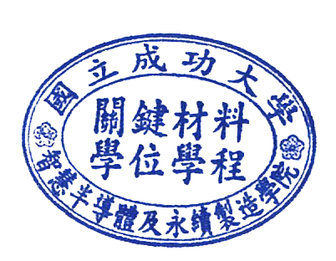
If you have doubts about the results, please contact the program within two weeks after the results announcement, Overdue appeals will not be accepted.

學位學程聯絡人 assistant of the program：歐小姐Miss Ou
Tel：06-2757575#65252#161
Email：ais2m_kmat@ncku.edu.tw

